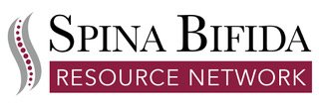

Participation in Virtual and In-Person Events
SBRN Policy
It is the policy of the Spina Bifida Resource Network (SBRN) to provide safe and open environments for attendance, participation and discussion at all groups, programs or events. SBRN reserves the right to deny a person from participating in any activity due to behavior or language that SBRN considers to be inconsistent with established program agreements and rules of participation, inappropriate, violent, threatening, harmful, lewd or otherwise causes significant discomfort, intentionally or not, to other SBRN participants, volunteers, invited guests or staff.
Conditions:
Conditions or situations that may warrant removal from a group, program or event, whether in person or virtual, include but are not limited to:
- Threatening or actual violent acts
- Perceived harassment, pestering or stalking behaviors, comments or messages
- Repeated sharing of overly intimate or inappropriate comments
- Breaking confidentiality
- Additional behaviors and comments that can reasonably cause harm or discomfort outside the scope of the topics being discussed or explored

